This file and the corresponding supplement summarize some of the main points of the planned URAP 2016-2017 research. Both are excerpts from much longer presentations, so the numbering of equations, figures and tables is not necessarily consecutive. Also, while condensing the stuff, I probably left out a few terms that I should have included and left in a few unneeded terms.

**DOSE-RESPONSE RELATIONSHIPS, SYNERGY ANALYSIS & INCREMENTAL EFFECT ADDITIVITY: DAE**

**Abstract**: Complex mixed radiation fields occur in interplanetary space. Little is known about their late effects on space travelers or their effects on “surrogate” endpoints such as chromosome aberrations. To plan relevant mixed ion beam experiments and to interpret their results, *in silico* synergy analysis default predictions, based on individual dose effect relations (IDER) for each component of the mixed radiation field and assuming no synergy or antagonism, are useful. For example, a default hypothesis of simple effect additivity is often used throughout biology. However, for more than a century pharmacologists interested in mixtures of therapeutic drugs have analyzed conceptual, mathematical and practical questions similar to those that arise when analyzing mixed radiation fields, and have shown that simple effect additivity often gives unreasonable predictions when the IDER are curvilinear. Various alternatives to simple effect additivity proposed in radiobiology, pharmacometrics, toxicology and other fields are also known to have important limitations.

We introduce a new alternative to simple effect additivity, “incremental effect additivity”, which is more suitable for NASA analyses and perhaps for other situations.

Eventually synergy analysis default predictions of the effects of mixed radiation fields will be replaced by more mechanistic, biophysically-based predictions. But optimizing synergy analyses is an important first step. We argue that if mixed beam experiments indicate little synergy or antagonism, NASA’s planning of further experiments, and perhaps NASA’s planning for missions beyond low-earth orbit, will be substantially simplified.

As seen above, a lot of the work has to do with IDER. A reference on IDER in general is the Wiki article

<https://en.wikipedia.org/wiki/Dose-response_relationship>. It is not a particularly good Wiki, but does contain some of the basic terms, a few relevant comments, and a few references to recent articles or web pages, so it can perhaps serve as a starting point. Googling “dose-response relation” or “dose-effect relation” turns up quite a bit of further Wiki level (or more advanced) material.

INTRODUCTION

*Background and Goals*

Mixed radiation fields are important in radiobiology, especially when considering cancer and other risks of space travel [reviewed in *(**1**)*]. A complex GCR (galactic cosmic ray) mixed radiation field is present outside of low earth orbit. The field includes potentially significant contributions from high linear energy transfer (LET) [see <https://en.wikipedia.org/wiki/Linear_energy_transfer>; introductory paragraph] ions of high charge and energy (HZE*(**2**)*). Generally the doses and dose-rates involved are low *(**3-5**)*. But chronic exposure over several years is worrisome and for many of the GCR components effective astronaut shielding is not feasible [reviewed in *(**4-6**)*].

*Synergy Analysis*

Synergy analysis deals with mixtures of “agents” such as therapeutic drugs or single- ion radiation beams. It makes predictions for mixture dose-effect relations based on individual dose effect relations (IDER) for each agent in the mixture, assuming no synergy or antagonism. Here “effect” might be cure probability for therapeutic drugs, or Radiation Exposure Induced Death (REID) for radiation fields, etc. The purpose of this summary is to explain how modern synergy analysis [reviewed in *(**7**)*] can help plan such mixed agent experiments and interpret their results.

For radiation, work on predicting and experimentally estimating mixture effects has been actively pursued for almost 50 years, e.g. *(**8-10**)*, and is still ongoing *(**1**)*. The literature on effects of agent mixtures, e.g. mixtures of therapeutic drugs in pharmacology (where drug-drug interactions can occur), of damaging chemicals in toxicology, of multiple stressors in evolutionary ecology, etc., began earlier and is more extensive [reviewed, e.g., in *(**7**,* *11**)*]. This general literature supplies prediction methods that are potentially applicable to mixed radiation fields, including not only simple effect additivity predictions but also various other methods now considered preferable to simple effect additivity in specific situations.

Current synergy analyses involve various mutually contradictory interpretations of “synergy”, corresponding to the different prediction methods. Reviews of the interpretation inconsistencies include *(**7**,* *12**,* *13**)*. To avoid terminological confusions it is therefore always advisable to specify which of the possible meanings are being assigned to “synergy” and to its opposite, “antagonism”; an international agreement on how to implement this clarification is reviewed in *(**14**)*.

*Default Hypotheses*

Much of our knowledge about single agents is summarized in their IDER. This suggests the following question *(**11**,* *15**)*.

Suppose we know each IDER for a mixture and have essentially no further information. What is the most reasonable default hypothesis about the effect of the mixture?

Things to note about this question are the following.

(a) The phrase “default hypothesis” refers to predictions that can be rejected by statistical analyses of observed mixture effects. Thus a default hypothesis must not only predict mixture effect size but also enable uncertainty analyses, such as estimation of 95% confidence intervals (CI), from information on IDER uncertainties. Then the CI can be used to help decide if observed mixture effects above (or respectively below) the default prediction indicate statistically significant synergy (or respectively antagonism) relative to that default hypothesis

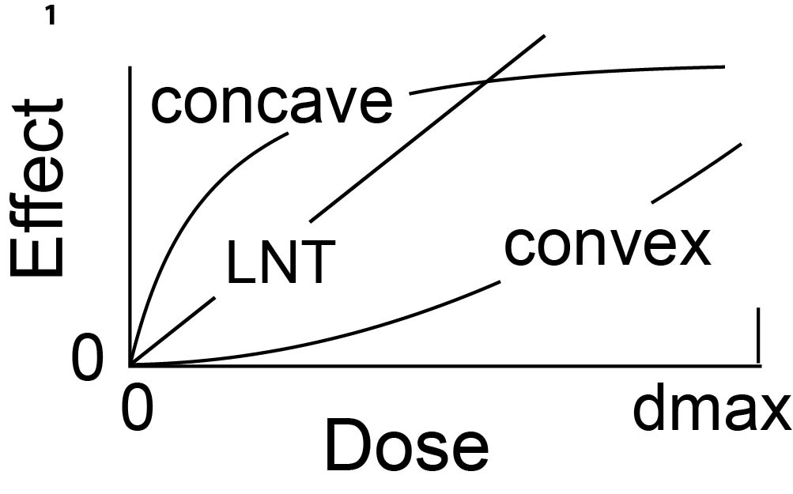**Fig. 1. Convexity and concavity.** Consider a dose-effect relation *E(d)* with *E(*0*)*=0, with positive slope, and with continuous second derivative d2*E*/d*d*2*.* If d2*E*/d*d*2  ≥ 0 over the entire dose range [0, dmax] of interest, the relation is convex. If the inequality is strict, i.e. d2*E*/d*d*2  > 0, the slope is increasing as shown, and the relation can be referred to either as “strictly convex” or just as “convex”. If the inequalities are reversed then substituting “concave” for “convex” gives the appropriate terminology. Thus a strictly concave curve has decreasing slope. If d2*E*/d*d*2=0 at all doses, *E(d)* is linear-no threshold (LNT). Radiation dose is measured in Gy (joules/kgm) or cGy with 100 cGy=1Gy or mGy with 1000 mGy=1Gy.

(b) Any general method of using IDER to get default hypotheses on mixture effects must be able to handle heterogeneous IDER shapes –e.g. some linear no threshold (LNT) as shown in Fig. 1, some strictly concave (Fig. 1), some strictly convex, and some for which d2E/dd2 changes sign, all in a single mixture.

(c) Most of the default hypotheses that have been suggested in the synergy literature emphasize using mathematical and computational manipulations of IDER rather than biologically or biophysically-based information in constructing default hypotheses [reviewed in *(**7**,* *16**)*]. As will be discussed, intentional avoidance of biological/biophysical arguments has important advantages, as well as its obvious disadvantages.

In analyzing the underlined question, an *N*-agent mixture with dose *dj* of agent *j* (*j*=1, …, *N*) will be considered, with the putatively known IDER denoted by *Ej(dj)*. Unless explicitly stated to the contrary we will assume each IDER has the following properties in the dose range from 0 to the largest dose (dmax) considered: *Ej(0)*=0 (i.e. background effect has been subtracted out); *Ej(dj)* is a two times continuously differentiable function; and the slope d*Ej*/d*dj* is positive for *dj* >0. Whether the second derivative is positive, zero, or negative is important in describing IDER curve shapes (Fig. 1).

*Examples of Dose Effect Relations*

In radiobiology, LQ (linear-quadratic) IDER are frequently used. For a single dose that is “acute” (i.e. so rapid compared to relevant relaxation times that it is effectively instantaneous), the relation is



where the following conditions and comments hold.

(a) *α* and *β* are non-negative constants and at least one of them is non-zero.

(b) If *β*=0, the IDER is LNT. Assuming instead *α*=0 gives the pure quadratic case,

 (2)

(c) An LQ curve is convex as defined and exemplified in Fig. 1. If *β*>0 the curve is strictly convex.

Many of the IDER used for analyzing non-targeted radiation effects are instead concave *(**17-20**)*. The IDER used most commonly in pharmacometrics are Hill functions *(**11**,* *15**,* *21**)*, often called “Fisk” functions in economics, reviewed in Supplementary Information S3.1.1. Some Hill functions are concave. Others are sigmoid, having positive second derivative for small doses, negative second derivative for large doses, one point of inflection, and approaching a finite limit for dose → +infinity.

*LNT IDER and Simple Effect Additivity*

The simplest example of a default hypothesis on *N*-component mixture effects is simple effect additivity. For example, suppose all the IDER are represented by LNT functions. Then *Ej(dj)= αjdj*, with *αj* >0, and the simple effect additivity default prediction for the mixture is mixture effect

 (3)

For error analyses the simple effect additivity default hypothesis includes the assumption of statistical independence for the individual contributions in the sums *(**22**)*. If the uncertainties of each IDER are known, then 95% CI for *S(d1,…,dN)* can be computed. Mixture CI are typically calculated by Monte Carlo simulation. In this LNT case, standard statistical formulae can also be used.

We henceforth write the simple effect additivity prediction as *S*, even if many different kinds of curvilinear IDER are involved, rather than only IDER that are LNT:

 (4)

(a) In Eq. (4) and from now on, it is assumed that the total mixture dose *d* determines each of the individual component doses, usually as a dose-independent fraction of the total mixture dose.

(b) As shorthand, we shall use *S(d)* to refer to the simple effect additivity default hypothesis as well as to the mixture dose-effect relation, Eq. (4), that the hypothesis predicts.

*Limitations of Simple Effect Additivity S(d)*

In practice *S(d)* is routinely used in planning experiments to make prospective power estimates. A default prediction of *S(d)* in the case that all IDER are LNT, with synergy or antagonism then judged by observed deviations from *S(d)*, is generally accepted, in radiobiology *(**22**)* and throughout biology. But, somewhat surprisingly, *S(d)* has often been found quite inappropriate as a default hypothesis if some of the component IDER are not LNT *(**7**,* *23**)*. *S(d)* often treats the changes in slope that curvilinearity implies in an unrealistic way *(**16**)*. One main argument has been that for non-LNT IDER using *S(d)* gives flatly incorrect predictions for so-called “sham mixtures” of an agent with itself *(**7**,* *16**)*, as exemplified in Fig. 2. Such problems with simple effect additivity *S(d)* have been discussed for more than a century *(**24**)*.

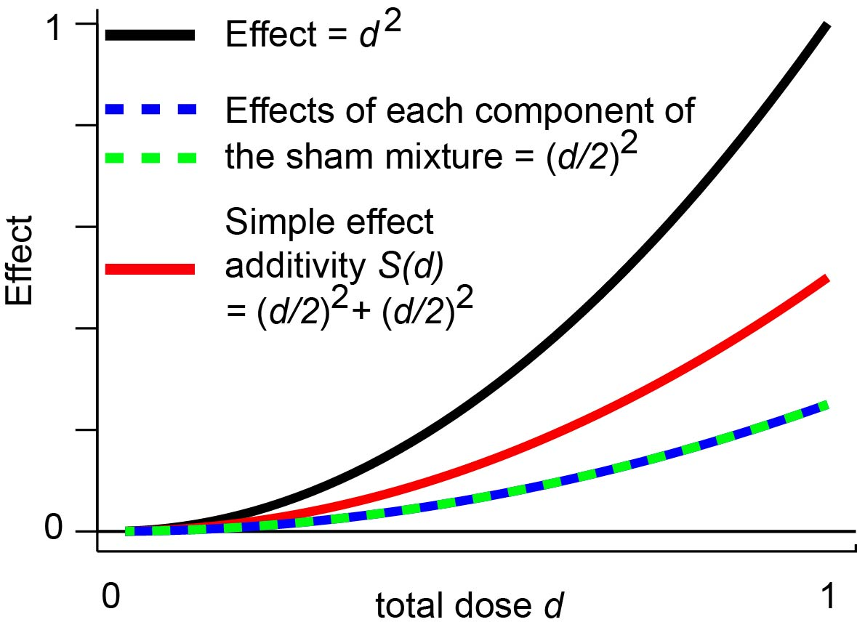**Fig. 2.** **An example where simple effect additivity is an underestimate.** Consider a hypothetical case where a single agent has pure quadratic IDER *E*=*d*2 (black line). Regard the agent as a 50-50 mixture of two agents, both of which happen to have the same dose response curve as the original agent. Then for total mixture dose *d,* each of the two agents contributes dose *d/2* and thus has effect *E*/4. Using simple effect additivity *I(d)* thus gives effect *E*/2 (red curve) rather than the correct answer *E*. In the special case that all component IDER are LQ, one can correct simple effect additivity by using Eq. (5) below instead. In general, however, some other method, such as incremental effect additivity, is needed to deal with mixtures having heterogeneously shaped IDER some of which are not LQ.

For a mixture of components that are similar but not exactly identical, corresponding discrepancies arise. For example, suppose every IDER for a mixture is convex as shown here. Then *S(d)* is likely to be an unrealistic underestimate (like the red curve). If every IDER is concave (Fig. 1) then *S(d)* is likely to be an unrealistic overestimate.

Therefore the default hypotheses now favored in radiobiology and other fields often differ from *S(d)*. An example is the biophysically motivated dual radiation action hypothesis *D(d)* on mixtures suggested by Zaider and others *(**25-30**)*. The hypothesis applies to mixtures only if each component has an LQ IDER, Eq. (1). For one acute dose the prediction *D(d)* differs from *S(d)* by using the square of a sum instead of a sum of squares for the LQ dose-quadratic term:

 (5)

In the sham mixture example of Fig. 2, Eq. (5A) gives the correct result for the mixture effect, twice as big as the incorrect prediction given by simple effect additivity *S(d)*.

Supplemental Information sections S4 and S6 discuss some other common approaches to synergy, comparing them to each other and to Eq. (5A); the linear isobole approach commonly used in pharmacology *(**16**)* is emphasized. For reasons discussed in S4, none of the known alternatives to *S(d)* proved suitable for the NASA calculations. For example, *D(d)* in Eq. (5) could not be used since many of the IDER used *(**6**,* *19**)* are not LQ; as will be discussed in the next section, some of these IDER include terms which describe non-targeted effects and make the IDER differ strongly from LQ dose-responses at very low doses.

We will therefore use a new default hypothesis, incremental effect additivity *I(d)*, defined in the Methods section. This new approach borrows ideas from the simple effect additivity and linear isobole approaches but circumvents flaws in the linear isobole approach (described in Supplementary Information S4.2.1 and S4.3.3) as well as the flaws in *S(d)* discussed above. *I(d)* is more suitable for our purposes, and perhaps in general, than other synergy analysis approaches.

**Table 1. Frequently used terms, acronyms, and symbols**

|  |  |
| --- | --- |
| Abbreviationa | Meaning and/or cross reference |
| IDER | Individual Dose Effect Relation(s) *Ej*(*dj*) for mixture component(s). |
| LQ | Linear-Quadratic IDER, Eq. (1). |
| LNT | Linear No-Threshold IDER; LQ IDER with *β*=0. |
| TE | Targeted Effect IDER Eq. (6). |
| NTE | Non-Targeted Effect IDER Eqs. (7) and (8). |
| *S(d)* | Simple effect additivity for a mixture, Eq. (4). Here *d* is total mixture dose. |
| *I(d)* | Incremental effect additivity for a mixture, Eq. (11). |
| *L* = LET= LET∞ | Linear Energy Transfer (keV/μm); Eq. (6) and associated text. |
| convex, concave | Standard mathematical terms that can describe changes in slope. Fig. 1. |
| dmax | The maximum mixture dose considered. |

MATHEMATICAL/COMPUTATIONAL METHODS

*Software*

We used the free, open-source computer language R *(**31**)*, initially designed for statistical calculations but now rapidly gaining acceptance among modelers *(**32**).* Our customized source codes are available, no strings attached, at https://github.com/rainersachs/NASA/master and at https://github.com/nopphons/NASA/blob/master/ 1RadResMain.

*Examples of Targeted and Non-Targeted Effect IDER. Omitted as not relevant to your project*

*Default Predictions for Mixtures*

Consider acute irradiation with a mixture of *N*≥2 different agents. The dose proportions *rj* that the different agents contribute to total dose ** obey the equations

 (9)

In our subsequent calculations *rj* will always be independent of dose. This is a typical pattern for acute irradiation at the Brookhaven National Space Radiation Laboratory. Using Eqs.(6), (7), and (9) in the simple effect additivity prediction (Eq. 4) gives

 (10)

*S(d)* will be compared to the incremental effect additivity prediction *I(d)*, described in the next subsection.

*Incremental Effect Additivity I(d)*

*I(d)* modifies *S(d)* predictions and linear isobole predictions. It uses small increments (i.e. derivatives) and “compositional inverses”. Compositional inverses are used in radiobiology when discussing RBE. They are needed when using effect, rather than dose, as the independent variable. They play a prominent role in computing isobole default hypotheses (Supplementary Information S4.1 and S4.2.1). The compositional inverse of a monotonically increasing function undoes the action of the function. For example, for x>0, so the positive square root function is the compositional inverse of the squaring function; note that the compositional inverse of x2 is not x-2. As another example, exp[ln(x)] = x and ln[exp(y)] = y so the functions exp and ln are compositional inverses of each other.

Suppose we have a mixture of *N* components and each IDER *Ej(dj)* has a compositional inverse function, denoted by *Dj(Ej)*. Then we will define incremental effect additivity *I(d)*, as a solution of the following first order, typically non-linear, separable ordinary differential equation.

 (11)

Here *d* is the total mixture dose. The square bracket with its subscript indicates the following calculations: First find the slope of the *jth* IDER curve as a function of individual dose *dj*. Then evaluate *dj* using the compositional inverse *Dj* with the argument of *Dj* being the effect *I* already present due to the influence of all the components acting jointly. Integrating the differential equation (11) using the initial value *I(d=0)*=0 defines the incremental effect additivity dose response relation *I(d*) for the mixture.

Using  in Eq. (11) instead of the seemingly more natural  is the key assumption made. It can be shown (Supplementary Information S4.3.1) that using  would merely lead back to simple effect additivity *S(d)*. Eq. (11) can be interpreted as follows. As the total mixture dose increases slightly, every mixture component contributes some incremental effect. The size of the incremental effect is determined in an appropriate way -- by the state of the biological target, specifically by total effect already contributed by all the components collectively (and not by the dose the individual component has already contributed). In this way different components appropriately track changes of slope both in their own IDER and in the other IDER. A more detailed derivation of Eq. (11) is given in Supplementary Information S4.3.1.

To clarify the mathematical manipulations involved in Eq. (11) one can use a hypothetical illustrative example with purely quadratic IDER, *Ej(dj)= βjdj*2. This is one of the quite exceptional cases where all the mathematical manipulations required to set up and solve Eq. (11) can be done with equations, rather than only by numerical simulations. Supplementary Information S4.4.1 gives a proof that in this case incremental effect additivity *I(d)* gives

 (12)

Here all the individual doses *dj* are given by Eq. (9) as linear functions of total dose *d*, so both *I(d)* and *S(d)* are themselves pure quadratic functions of *d*, but with different coefficients. Comparing Eq. (4) to Eq. (12) shows that the biophysically-based default hypothesis *D(d)* of dual radiation action and incremental effect additivity *I(d)* give the same predictions in this special case, even though *I(d)* is calculated by Eq. (11), which: (a) can be applied even when the IDER are not LQ; and (b), does not use biophysical arguments.

DAE the following paragraph contains an ad hoc extra assumption. Your project is mainly to see what happens when one uses a more reasonable approach. In integrating Eq. (11) it can sometimes happen that *I* becomes so large that it approaches, reaches and then exceeds the maximum *Ej* for a particular component. Then as *I* approaches maximum(*Ej*) from below, the component in question makes a smaller and smaller contribution to *dI/dd,* since the derivative of *Ej* at its maximum is zero. For values of *I* greater than maximum(*Ej*) the contribution of the *jth* component will here be taken to be zero, as it was at maximum(*Ej*). This extra assumption makes incremental effect additivity applicable over dose and effect ranges sufficiently large for our calculations, as explained in more detail in Supplementary Information S3.1.2 and S4.3.3. Lots of stuff irrelevant to your project is omitted here.

**DISCUSSION**

Synergy analysis helps plan mixture experiments and interpret their results using IDER-based computations. It requires choosing a default hypothesis that defines what particular definition of synergy is being used *(**7**)*. Simple effect additivity *S(d)*, given by Eq. (4), is the most obvious default hypothesis, but is often not the best *(**7**,* *15**,* *16**,* *33**,* *34**)*. We here compared *S(d)* with incremental effect additivity *I(d)*. Lots more irrelevant stuff omitted here

*Advantages and Disadvantages of Synergy Analysis*

General Considerations

Ultimately, estimating astronaut cancer risk due to radiation exposure will require biophysically-based knowledge of cancer etiology (blue path shown in Fig. 7). IDER-based synergy analysis default predictions of mixed beam dose effect relations (dashed arrow in Fig.7) are only temporary expedients *(**15**,* *16**)*. Such expedients are much less reliable than predictions based on biophysical understanding. But, importantly, *(**1**,* *7**,* *16**)*, the expedients are typically orders of magnitude faster, cheaper and simpler.

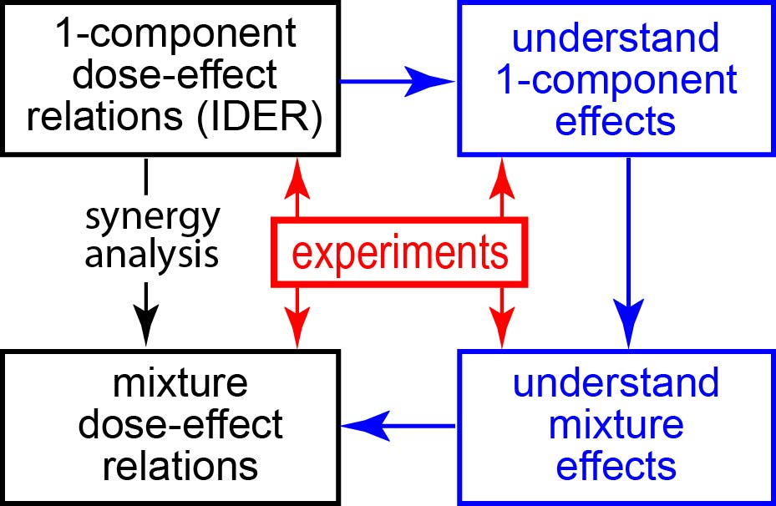 **Fig. 7. A long hard road or a temporary short-cut.** Eventually, but probably not soon, default predictions about GCR mixed field damage based solely on IDER (leftmost downward arrow) will be replaced by biologically-based predictions that incorporate whatever synergy or antagonism actually occurs (blue path). For the time being, optimizing the far simpler short-cut is important.

Any IDER-based approach produces only a default hypothesis. If a mixture has substantial agent-agent interactions not encapsulated in the component IDER, synergy or antagonism in the sense of that hypothesis is involved. IDER-based analyses are needed to define synergy but cannot predict it *(**9**)*. If there is major synergy or antagonism, biophysical insights and/or multiple (expensive) mixture experiments are needed to clarify the situation *(**1**,* *4**,* *7**,* *16**)*

If in fact there is no major synergy or antagonism then mixture results can be predicted from observed mixture component IDER. A severe combinatorial complexity problem, that in general a mixture result cannot be extrapolated even to a mixture with the same components but in different proportions, is largely circumvented, a drastic simplification for mixtures containing many different components. If accurate *in silico* IDER-based defaultpredictions on mixed beam effects can be found, NASA’s planning and interpretation of mixed beam experiments, and perhaps even NASA’s planning for missions beyond low earth orbit, can be very substantially simplified using such predictions.

Using *I(d)*

Sometimes, like linear isobole analyses *(**16**)*, *I(d)* can mimic biologically-based arguments. Examples include automatically incorporating NTE saturation and the fact that in Eq. (12) *I(d)* gives an equation previously derived from mechanistic considerations of pairwise lesion interactions. That is gratifying in these special cases, but it is unfortunately not a general feature. For example given two IDER that are LQ, not just pure quadratic, the biophysically based prediction Eq. (5) and the default prediction using *I(d)* in general differ, as shown in Supplementary Information S6.

BIBLIOGRAPHY

1. Norbury JW, Schimmerling W, Slaba TC, Azzam EI, Badavi FF, Baiocco G, et al. Galactic cosmic ray simulation at the NASA Space Radiation Laboratory. Life Sci Space Res (Amst). 2016;8:38-51.

2. Barcellos-Hoff MH, Blakely EA, Burma S, Fornace AJ, Jr., Gerson S, Hlatky L, et al. Concepts and challenges in cancer risk prediction for the space radiation environment. Life Sci Space Res (Amst). 2015;6:92-103.

3. Badhwar GD, Cucinotta FA, O'Neill PM. An analysis of interplanetary space radiation exposure for various solar cycles. Radiat Res. 1994;138(2):201-8.

4. Kim MY, Rusek A, Cucinotta FA. Issues for Simulation of Galactic Cosmic Ray Exposures for Radiobiological Research at Ground Based Accelerators. Front Oncol. 2015.

5. Slaba TC, Blattnig SR, Norbury JW, Rusek A, C.L. T, Walker SA. NASA/TP-2015-218698. GCR Simulator Reference Field and a Spectral Approach for Laboratory Simulation. Hampton, Virginia: NASA Langley Research Center, 2015 NASA/TP-2015-218698.

6. Cucinotta FA, Kim MH, Chappell LJ. Space Radiation Cancer Risk Projections and Uncertainties – 2012. Hanover, MD; <http://ston.jsc.nasa.gov/collections/TRS:> NASA Center for AeroSpace Information, 2013.

7. Geary N. Understanding synergy. Am J Physiol Endocrinol Metab. 2013;304(3):E237-53.

8. Deen DF, Williams ME. Isobologram analysis of X-ray--BCNU interactions in vitro. Radiat Res. 1979;79(3):483-91.

9. Lam GK. A general formulation of the concept of independent action for the combined effects of agents. Bull Math Biol. 1994;56(5):959-80.

10. Wuttke K, Muller WU, Streffer C. The sensitivity of the in vitro cytokinesis-blocked micronucleus assay in lymphocytes for different and combined radiation qualities. Strahlenther Onkol. 1998;174(5):262-8.

11. Foucquier J, Guedj M. Analysis of drug combinations: current methodological landscape. Pharmacol Res Perspect. 2015;3(3):e00149.

12. Boedeker W, Backhaus T. The scientific assessment of combined effects of risk factors: different approaches in experimental biosciences and epidemiology. Eur J Epidemiol. 2010;25(8):539-46.

13. Berthoud HR. Synergy: a concept in search of a definition. Endocrinology. 2013;154(11):3974-7.

14. Tang J, Wennerberg K, Aittokallio T. What is synergy? The Saariselkä agreement revisited. Frontiers in Pharmacology. 2015;6:181.

15. Greco WR, Bravo G, Parsons JC. The search for synergy: a critical review from a response surface perspective. Pharmacol Rev. 1995;47(2):331-85.

16. Berenbaum MC. What is synergy? Pharmacol Rev. 1989;41(2):93-141.

17. Brenner DJ, Little JB, Sachs RK. The bystander effect in radiation oncogenesis: II. A quantitative model. Radiation Research. 2001;155(3):402-8.

18. Cucinotta FA, Chappell LJ. Non-targeted effects and the dose response for heavy ion tumor induction. Mutat Res. 2010;687(1-2):49-53.

19. Chang PY, Cucinotta FA, Bjornstad KA, Bakke J, Rosen CJ, Du N, et al. Harderian Gland Tumorigenesis: Low-Dose and LET Response. Radiat Res. 2016;185(5):449-60.

20. Cacao E, Hada M, Saganti PB, George KA, Cucinotta FA. Relative Biological Effectiveness of HZE Particles for Chromosomal Exchanges and Other Surrogate Cancer Risk Endpoints. PLoS One. 2016;11(4):e0153998.

21. Chou TC. Theoretical basis, experimental design, and computerized simulation of synergism and antagonism in drug combination studies. Pharmacol Rev. 2006;58(3):621-81.

22. Dicello JF, Christian A, Cucinotta FA, Gridley DS, Kathirithamby R, Mann J, et al. In vivo mammary tumourigenesis in the Sprague-Dawley rat and microdosimetric correlates. Phys Med Biol. 2004;49(16):3817-30.

23. Loewe S, Muischnek H. Ueber Kombinationswirkungen. I. Mitteilung Hilfsmittel der Fragestellung. Archiv for Experimentelle Pathologie und Pharmakologie. 1926;114:313-26.

24. Fraser TR. Lecture on the Antagonism between the Actions of Active Substances. Br Med J. 1872;2(618):485-7.

25. Zaider M, Rossi HH. The synergistic effects of different radiations. Radiat Res. 1980;83(3):732-9.

26. Bird RP, Zaider M, Rossi HH, Hall EJ, Marino SA, Rohrig N. The sequential irradiation of mammalian cells with X rays and charged particles of high LET. Radiat Res. 1983;93(3):444-52.

27. Zaider M. Concepts for describing the interaction of two agents. Radiat Res. 1990;123(3):257-62.

28. Berenbaum MC. Concepts for describing the interaction of two agents. Radiat Res. 1991;126(2):264-8.

29. Suzuki S, Miura Y, Mizuno S, Furusawa Y. Models for mixed irradiation with a 'reciprocal-time' pattern of the repair function. J Radiat Res. 2002;43(3):257-67.

30. Furusawa Y, Aoki M, Durante M. Simultaneous exposure of mammalian cells to heavy ions and X-rays. Adv Space Res. 2002;30(4):877-84.

31. Matloff N. The Art of R Programming. San Francisco: No Starch Press; 2011.

32. IEEE. Institute of Electric and Electronic Engineers: Top 10 Programming Languages 2014 [03/12/2015]. Available from: <http://spectrum.ieee.org/computing/software/top-10-programming-languages>.

33. Lorenzo JI, Sanchez-Marin P. Comments on "Isobolographic analysis for combinations of a full and partial agonist: curved isoboles". J Pharmacol Exp Ther. 2006;316(1):476-8; author reply 9.

34. Wang CK, Zhang X. A nanodosimetry-based linear-quadratic model of cell survival for mixed-LET radiations. Phys Med Biol. 2006;51(23):6087-98.